International Comenius Week 2023
Refugee education in the UK
27th – 31st March 2023
We are living in a world that has become increasingly reliant on globalisation and international links, yet the current realities of climate change, Brexit and a global slowdown are making living and working in other countries harder than it used to be. We would like to offer students from our European partners in Comenius the chance to come to Winchester to share ideas, experiences, and reflections about how Brexit has affected attitudes to identity and refugee education in the UK during our International week.
Winchester is the ancient capital of England with many historical wonders situated nearby and only an hour by train from London. Our university is in the centre of the city, and you will be hosted by students and staff from the Institute of Education, which sits within the University of Winchester.
Activities during the week:
- Campus tour
- The chance to sit in on seminar sessions with our undergraduate cohort
- A visit to a Primary school (4 – 11 years)
- Workshops on aspects of the curriculum
- Tour of Winchester
- Trip to Stonehenge
- Trip to Oxford
- Chance to present workshops to peers
- Social activities with English students and fellow international week attendees

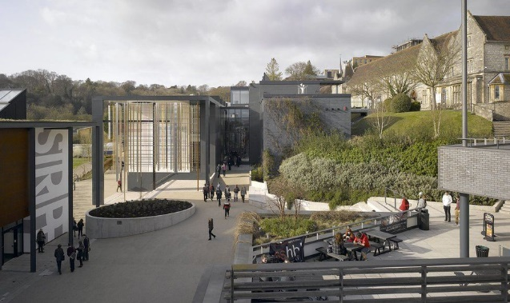

Costs:
Attendees to pay for flights, food, and accommodation while here:
Airbnb: Holiday Rentals, Cabins, Beach Houses, Unique Homes & Experiences
Winchester Hotel | Hotels in Winchester | Premier Inn
The University will pay for transport and entrance to visits during the week
All course materials will be provided
We will host a meal for the group at the end of the week
Arrivals on Sunday 26th March and the programme will start on campus on Monday 27th March 2023 and will finish at Midday on Friday 31st March 2023.
Best airport to fly into is London Heathrow and then you can either catch the train or a coach to Winchester which is 60 miles southwest of London. Please make sure that you have looked at the Visas needed for entry and that you have followed the Covid – 19 guidance for entry into the UK. Visit the UK as a Standard Visitor - GOV.UK (www.gov.uk)
If you plan to get the train you would need to travel into London on the underground and get to Waterloo to catch the train out from there.
Cheap Train Tickets | Travel Safely | South Western Railway
Coach Travel & Airport Transfers | National Express

The week will be conducted in English so a good working knowledge will be required (Level B1).
No ECTS are attached to this International Week.
Please be aware that our wish to hold this International week face to face is dependent upon national Covid – 19 guidelines. We may need to adapt part or all of the programme depending on any Government guidelines on face-to-face meetings.
Participants are kindly asked to try to book travel arrangements which can be changed or cancelled with little additional costs wherever possible. The University of Winchester cannot accept liability for any costs howsoever arising.

